**ENGINEERING DESIGN PROCESS**

Prepared by

**Andino Rochon, Karan Shah, Rishi Patel**

University of Georgia

**February 2019**

# 

# TABLE OF CONTENTS

PREFACE 3

BACKGROUND 4

ENGINEERING DESIGN 4

THE DESIGN PROCESS 5

1. DEFINE THE PROBLEM 6

2. GATHER PERTINENT INFORMATION 8

3. GENERATE MULTIPLE SOLUTIONS 10

4. ANALYZE AND SELECT A SOLUTION 13

5. TEST AND IMPLEMENT THE SOLUTION 15

REFERENCE 17

# 

# 

# PREFACE

This document is based on our current knowledge in the engineering design process and can be used to show our plan for what we intend to create this spring semester of Introduction to Computer Systems Engineering. We intend to use this document throughout all of our design to make sure we keep our problem we will solve in mind and the requirements we would like to meet so that our product is the best it can be.

This document reflects the work and ideas of Andino Rochon, Karan Shah, and Rishi Patel though our problem solving and design process ideas. We would like to also give a thanks to our professor, Benjamin Manning, for the resources and assistance he has given us to make this entire project possible.

# BACKGROUND

Taking medication is already difficult enough. The user has to apply strength in order to unscrew the hard ridges of the cap. They also have to hold the medication bottle steadily in their hand while they pour the pills out in their hand. Sometimes, the user might even forget to take their medication as the bottle itself does not visibly remind the user when to take their medication. Taking medication would be extremely hard for someone with diseases or disorders. On the other hand, sometimes it might be too easy for someone to take medication as these bottles allow someone with past drug issues to easily access these pills. This problem has been occurring persistently and has been impacting all ages of people. Surprisingly, there is still not a modern solution to it. That is where our team has come in to develop and design a modern solution.

**ENGINEERING DESIGN**

Engineering design can be extremely complicated when your sit down and want to design something. Sometimes an engineer is told to solve a broad problem and they have to look through how to make a general solution. To start with trying to solve a problem you have to find the exact problem. Sometimes that problem can stem to multiple different problems you never even intended to solve. We started with the problem of people with certain disabilities not being able to take their medicine easily or keep track of when they did. With design you never know if you will later realize the other problems your idea can solve. Once we got into the plans of the design and use for this project we jumped back to what problem we were solving.

There was many more problems our product also could solve, a big one being drug abuse. This became another big focus on our project as this not to just be a product to help someone disabled but also to help the drug problem in America all together. This could be a step in the right direction with making medicine a lot more safe and secure for everyone.

Throughout the rest of the design process will we keep all of these focuses in mind and will solve our problem the most efficient way possible as we still stick to our design plan laid out in this document.

# 

# 

# 

# 

# 

# 

# 

# THE DESIGN PROCESS

The design process is an adequate method that teams use in order to develop or innovate an idea. The design process is not a simple one. This is because there is not one solution involved when it comes to designing devices or new software. Teams may have to backtrack a lot in order to finally get the solution that fits all their needs. However, no matter how long it takes for the solution to come about, the design process can be simplified into 5 simple steps:

1. Define the problem

2. Gather pertinent information

3. Generate multiple solutions

4. Analyze and select a solution

5. Test and implement the solution

The first step involves defining a problem. Without a known problem, there can not be a functional solution to the problem. After the problem is found, the next step involves gathering all necessary information for the problem. Without any factual information, it would be difficult to find a solution. The next step is to think of multiple solutions that would fit our problem. By having multiple solutions, you can break down the pros and cons of each one. After doing this, picking one solution would be the next step. The final solution would be something that is ideal to the user and manufacturer. An ideal solution would be something that can be easily scaled and used. After picking a solution, the next step is to create, test and implement the solution. This would be to insure the solution is a viable option and works just as how you intended.

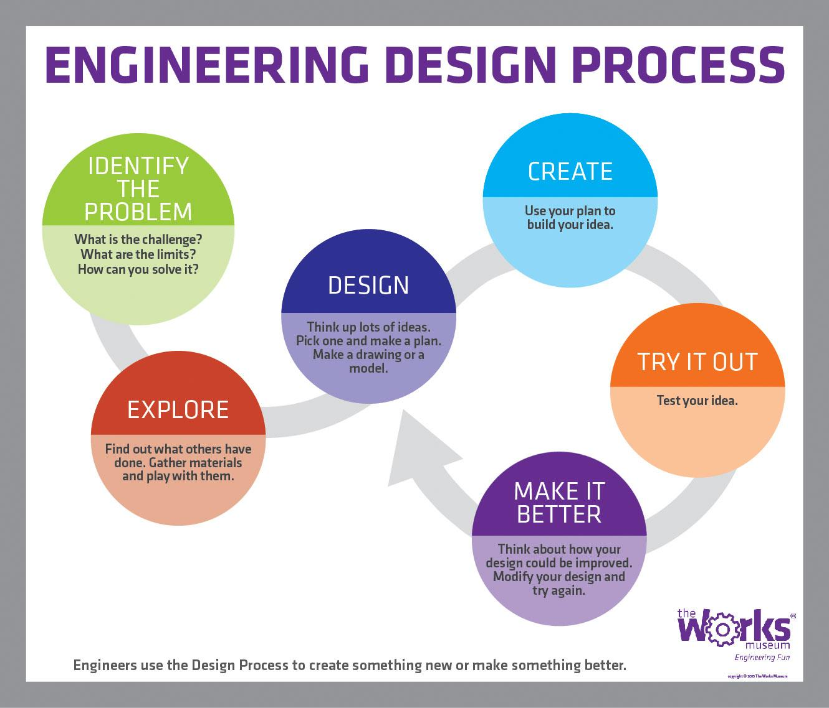

# 1. DEFINE THE PROBLEM

In 1999, there was 3,442 overdose deaths involving prescription drugs in America. In 2017, the CDC records there was 17,029 overdose deaths involving prescription drugs. Currently our nation is in an opioid epidemic and there is not much that is being done to fix this rising problem. Over 55 percent of Americans are prescribed medicine today and 1 in 5 Americans suffer from some mental disability. People suffering from a mental illness or disability are more likely to abuse their medication, yet everyone is still given a pill bottle with more than enough medication for an overdose. There are also many people with physical disabilities that could have a very hard time knowing when and how much of their medicine to take. With the combination of all of these issues this is a big reason to why our nation is in the opioid epidemic.

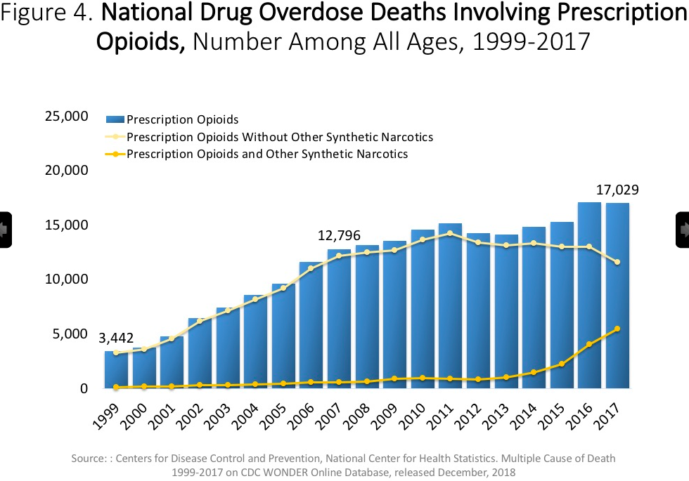

***Identify and Establish the Need***

With death rates from prescription drugs getting to be even higher than heroin and other illegal drugs and many more people with disabilities not being capable of taking their medicine; big changes need to be made if we want this problem to be stopped. Mental health has been a big talk in our society in this day in age. Unlike in the past, more people are more comfortable talking about mental health and there is more of a push from society to get help when suffering from any of these illnesses or disabilities. With more people talking about mental health is has given to the rise for more people to go get this assisted help, which in some cases can involve therapy and in other cases can involve being prescribed medication. This is a big problem with people being given all this medication with no way to track how they are taking in or giving them any restraint to how the medicine can be used.

This is not just an issue with those with mental disabilities but it can also be an enormous issue with those who have long or short term physical disabilities. Someone who is blind that is prescribed a medication may not be able to keep track of how much medicine they need to take at a time and if they do not have someone that can assist them they could have a big problem. Someone with a short term physical disability would play a big role in this issue as well. Many patients are prescribed opioids after having an intensive surgery or getting an injury. Opioids can be very powerful and dangerous and if not used responsibly someone can get themself into many harmful situations including: addiction, overdose, or giving it to others who are not prescribed it. When people are on these drugs their brain doesn't think the same way it does normally, yet they are still given that pill bottle filled with more than enough for an overdose. This puts so many people in a dangerous situation with opiods and really no buffer for them to be protected from accidental abuse.

There is all of these problems going on with prescription medicine not being used responsibly; with either that being someone just being irresponsible or they have some physical or mental disability that affects them where they cannot keep track of the medicine they are taking the way they should. Still today there has not been any change to the way medicine is distributed, yet there continues to be a huge rise in these issues and the opioid epidemic getting much worse year to year.

***Develop a Problem Statement***

With all of these problems in the irresponsible distribution of medicine affecting different groups of people, a solution needs to be made. Giving people pill bottles with all of this medication to potentially be abused or given to others is not the answer anymore. Medicine needs to be distributed by our pharmacys, hospitals, and doctors in a more responsible way where consumption of these drugs can be regulated for those with disabilities and maybe one day for everyone.

This growing drug problem in America can be solved when attacking from the source of the problem, irresponsible distribution. Someone who has a mental or physical disability could not understand or misuse their prescription and could potentially be harmed when we could have a product that only allows them to take what they need to take at that certain time with no way of accidental or purposeful misuse. Medicine should be distributed in pill bottles that cannot be fully accesses, but instead are another use of easy partial distribution of the current dosage needed at that time.

***Establish Criteria for Success***

There is many things that are very important if we would like to fix this on going and increasing problem. We need a product that is able to replace the current pill bottle so we look at a few features that are extremely import.

1. Portability

It is extremely important that we have this product be a similar size to a pill bottle so patients are able to take it places with them without it being any different from the generic pill bottle.

1. Cost

Money is one of the biggest problems will trying to fix any problem. You can say your going to fix a problem, but the real question is who is going to be able to pay to fix this problem. We need to find the best low cost solution for a pill bottle so that it is possible.

1. Ease of use

Pill bottles are simple in the fact to where you open the bottle and take your medicine. The goal of a product is even further simplification, where the medicine does not have to be taken out, but instead the right amount is given to you.

1. Serure

The solution should be secure so it is truly fixing the problem. Extreme detail needs to be put into this product so any user is guaranteed to be safe with the product.

These points are going to be the basis which what we will build this product on. The product will only truly be a solution if we can maximize these 4 areas above with maintaining other small important features we will need to add. Every single feature we decide to have on this product we will ask the following questions:

* Does this feature affect the portability of the product?
* Is adding this feature going to be to costly and drive the price of the product?
* Will adding this feature make this product more confusing or easier to use?
* Will this feature be compromising any security on the product?

**2. GATHER PERTINENT INFORMATION**

Some individuals have trouble taking their daily doses of medicine whether it comes to the problem with addiction or having a physical or mental incapacity to take the medicine. According to drugabuse.gov, 12% of young adults abuse prescription medicine. One major problem with the drug industry its incompatibility with blind patients. According to studies by ncbi.nlm.nih.gov, blind patients have difficulty with dosages and reading labels which pertain to how to use the drug. 90% of the visually impaired population live in developing countries which limits their accessibility to outside help when taking medicines prescribed to them. Around 285 million people worldwide are visually impaired and a solution is necessary to these individuals who are on medication for their disabilities. Another major problem with medication users are the patients that have Alzheimer’s. This problem is nerving since the user does not know if they took their medications or not and can easily result in an overdose if kept unsupervised.

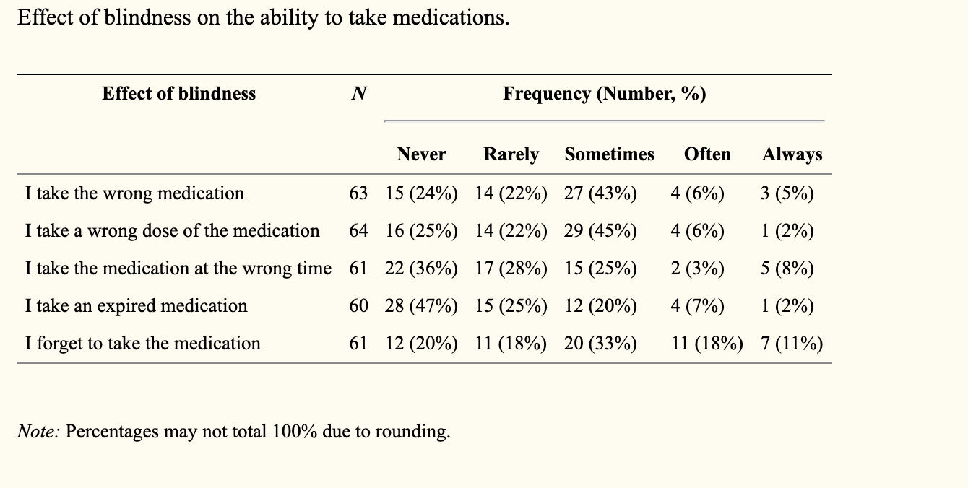

According to this table, a majority of visually impaired patients have complications while trying to take the medication they are supposed to take. Many of these patients indicated that it was necessary that they use the aid of people with normal vision to take their medications.

Some areas that need to be addressed are:

* Is the problem real and its statement accurate?
* Is there really a need for a new solution or has the problem already been solved?
* What are the existing solutions to the problem?
* What is wrong with the way the problem is currently being solved?
* What is right about the way the problem is currently being solved?
* What companies manufacture the existing solution to the problem?
* What are the economic factors governing the solution?
* How much will people pay for a solution to the problem?
* What other factors are important to the problem solution (such as safety, aesthetics and environmental issues)?

There are not many solutions out there for this problem however. One product that tries to tap into this market is a pill box that opens the compartment for each day of the week and each compartment already has the medication the patient needs to take. Some problems with this is that someone still has to fill each of the compartments with the right medication and in developing countries where healthcare assistance is limited, it is very difficult to properly use it if you were visually impaired. One area this product excels in is for people who are developing Alzheimer. These patients often forget what medicine they are taking or how much of each to take every day so a compartment that is pre filled with the correct medication is very useful for them.

There are many pill dispensers available in the market but one overarching problem with this is that these products are very expensive and require another person to constantly refill the tub. The ones that are tamper proof almost hit the mark of $1000. These are great products on their own but the ease of use for the user is difficult and maintaining this expensive machinery will cost more than anticipated.

One way to solve all these problems in one product is to make the product versatile to every patient. A dispenser that automatically dispenses the correct amount of medication and does so on a timely schedule while alerting the user is one way to solve this problem. This would be easy for the patient since all they have to do is wait for their medicine to be dispensed and a visual and audible alert will be activated so the user knows when to take their medication. This product would be given to the pharmacy’s or the doctor and the settings for the product will be set by them so there is no way for the user to get the medication early or on the wrong time. This will eliminate the problem of constantly having a family member or a nurse organizing their medications and giving it to them on a timely manner. For developing countries, this solution will address the problems of patients not having immediate access to other people who can help them take their medication.

This product would have to very cost effective because it is essentially replacing a cheap to manufacture plastic pill bottle. This product will be reusable and cost effective so that the longer you use the product and ditch conventional plastic pill bottles, it will eventually become cheaper to use that instead of a regular plastic pill bottle.

**3. GENERATE MULTIPLE SOLUTIONS**

***Background***

Our team has proposed solutions that will potentially help people with physical or mental disabilities or someone with past drug problems to dispense their medically prescribed pills at ease. This is an important issue in today’s society as drug addiction has become increasingly common because of the wide availability of drugs and the ease of access to them. Another issue that we would like to tackle is the fact that people with certain disabilities and disorders such as Parkinson’s disease and arthritis have it harder dispensing pill from a regular container. The ridges inside the cap make it difficult for anyone with weak hands or hand tremors to open the container. Thus, designing a mechanism that would allow the user to automatically dispense pills at will or at certain set times would make their lives a lot easier and a lot safer as well. The mechanism would also benefit people with a history of drug problems as the machine would only dispense pills at certain times, thus preventing overdoses.

***Solutions:***

## Solution 1 - (multiple medications)

The first solution that we have in mind is to implement a machine that can hold multiple types of pills at once. This would allow a more universal design as the user could put all their medications in the same device and not have to worry about any of their prescriptions at different times. One way we could possibly implement this in a device is to have different compartments for each medication. This way, the user does not have to buy seperate devices for each of their medications.

Pros for this solution include

1) One centralized device for medications.

2) Cheaper for user as they only have to buy one device.

Cons for this solution include

1) Harder to design a machine that can dispense different sized pills.

2) Would have to figure out a method for the machine to distribute 2 different medications at the same time if prompted.

## Solution 2 - (only one medication)

In this solution, our device would only hold one type of medication. This would make it a lot easier for us to design the actual machine that dispenses the parts. Thus, the machine would be a lot simpler to use in which case a lot more people could use it. The design would be simple as we could have one prism shaped box in which the user could insert their medication on top and the device would then dispense pills at a timely manner through the bottom. However, by choosing this solution, the user could only have one medication per device, forcing them to obtain a new one if the user had more than one medication they would want to dispense.

Pros for this solution include

1) A simple design which would allow anyone to use as their would be no learning curve associated with it.

2) The machine would handle timings a lot more efficiently as it would only have to dispense the same type of medication. This would allow us to create devices specialized to each shape a pill might have.

Cons for this design include

1) Only one type of medication can be handled.

2) User would have to buy multiple machines for in case they had multiple medications.

**Solution 3 - (one medication, locking mechanism)**

This solution involves dispensing one medication, however instead of allowing the user to access the pills after they have been put in, the machine locks the pills inside until they all have been dispensed in a timely manner. This would effectively reduce the chance of overdoses in case the user had a history of overdosing on medication or was not understanding how much they needed to take. The user would preset the times of dispense on the device and only obtain those pills at those preset times. For the structure of this machine we could also have a rectangular prism style design. This means the doctor or pharmacist inserts the pills at the top and once they close the lid, the lid locks until there are no more pills to dispense for that patient.

The pros for this design include

1) This design prevents overdoses by dispensing pills at a timely manner.

2) The lid would automatically unlock after there are no more pills to dispense, allowing the user to dispense another medication if they wish too.

The cons of this solution include

1) It would be impossible to dispense pills at will in case the user was in a emergency.

2) It would be impossible to refill the device until after all the pills were finished.

**Solution 4 - (multiple medications, locking mechanism)**

In this solution, we combine all elements of our previous solutions into one. This device would be capable of handling more than one medications and also would lock itself after being filled. The only time it would unlock would be if a medication needs to be refilled. This machine would presumably require a learning curve as we would have to redesign it in order to hold and dispense different shaped medications. However, a huge benefit to this device would be that it would provide one centralized solution to people with disorders and diseases and people with drug problems.

Pros for this solution include

1) Holding more than one medication.

2) Prevent taking medication at the wrong times

Cons of this machine include

1) Not being able to manually dispense medication

2) Might have a learning curve to new users

3) Cannot refill medication until machine unlocks by itself.

**4. ANALYZE AND SELECT A SOLUTION**

***Functional analysis***

The basis of our product is simple since it is just a pill dispenser but with the added on components, it becomes a product that is very versatile and easy to use. For the majority of the processing, we will be utilizing an Arduino board. This will handle the lock and the rate at which the bottle dispenses the pills. For now this board will work but in order the product to become cost effective and easy to produce, custom hardware will have to be produced. The main mechanism pushing the pills will be a servo motor so that any pill size can be programed in the machine and it will successfully be able to dispense the pills. A light along with an audible tone will indicate when the pills are ready to be dispensed. The only way to edit the timing on the dispenser will be through a micro USB port that can only be accessed by the physician or the pharmacist. The secure lid at the top will prevent the patient from opening the bottle and abusing the medication.

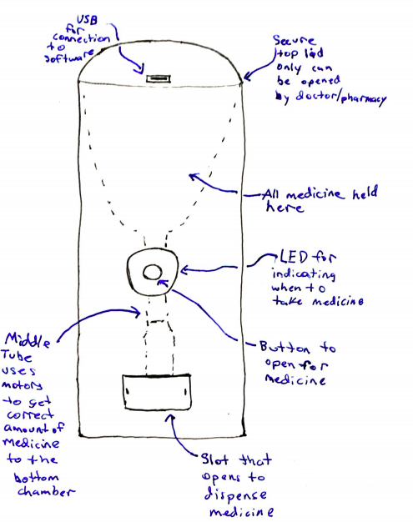

***Ergonomics***

Since this product is geared towards people with different disabilities, our product has to be versatile to fit all their needs. For visually impaired people, the dispenser makes an audible tone for the patient to listen to so that they can now when to take it and it will automatically dispense the right amount. For others using this, the top of the jar will lock so it will help prevent prescription abuse. Once the pills are ready to be dispensed the user clicks the button and the pills are dispensed on the side of the bottle which makes it easy for the patient to grab the medication efficiently. This design has to be compact since it will be replacing a small pill bottle that is commonly used. This dispenser will look similar to ordinary pill bottles so it discreetly blends in as a regular pill bottle.

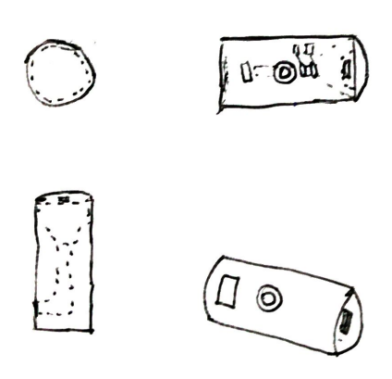

***Manufacturability***

The manufacturability of our product is fairly simple. Manufactures will have no problem making this product as it is a simple rectangular prism design. This will also reduce costs for both the manufacturer and user, which makes it beneficial for both parties to produce this one solution. This solution also uses inexpensive metal to build it. This allows the company to maintain long term profits and also reduces the cost for the user allowing them to buy more than one.

***Product Safety***

The product is designed with full user safety in mind. Safety was of utmost importance in designing this product because the entire purpose is to stop drug addictions as well has to help people with disabilities and disorders. Without keeping product safety in mind, there would be no users of our product. To insure product safety, we have made it child proof as there will be locks on the lids. This allows only users to obtain the pills even after the lids have been unlocked. The product will also be a sealed environment where outside chemicals will not impact the freshness of the medication.

***Economic Analysis***

Our product will be sure to hit the market and make a positive impact. This is because we assure you that there is no like product out in the market as of right now. We have created a niche in the market that our team will dominate. We hope to be profitable in a couple months as opposed to a few years like some companies. This is because people will see a need for a product like this in their home and will be inclined to buy it.

***Regulatory***

Our product will make sure to comply with safety standards that are handed out by the government. We will insure to follow these guidelines very closely when making our final design and product. Our electronics will be tested thoroughly to be sure they copy with modern safety features. We will also be sure to check regulatory guidelines when it comes to wt material is allowed in making the sealed container lids.

**5. TEST AND IMPLEMENT THE SOLUTION**

Now that our team has laid out all of our design process in each stage, and come to an idea of exactly what our product is going to be it is time to get into the last stages of building and perfecting our product.

***Prototype***

First we will start working on prototype which will have 2 main components to it. First will be the actual tangible product that we will be using a 3D printer for the shell and using Arduino and other comments needed to get it to function as we need for electronics. We will have an LED to indicate when the medicine is ready, vibration to also vibrate when it is ready (to help the visually impaired), a button for the user to press when they are ready to receive the medicine, and an USB to connect to the doctor/ pharmacy software to set all of the times to dispense medicine and dosage. This software will be the other large part of our project. This will connect the doctor with the patient and only allow the container to be opened if the doctor is connected to the device and logs in to open.

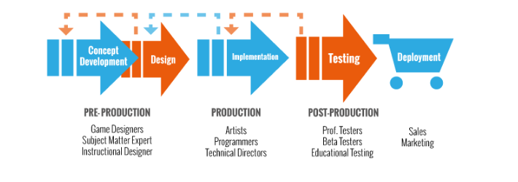

***Concurrent Engineering***

Once we have build our first prototype and along the way we may run into problems or more ideas we would like to change in our product. In this stage we will work to perfect our model and go back through the design process if needed so that everything is how it should be. One big thing we will look at through the entire process is cost. This is something our group sees is very important and will work to drive cost down as much as possible so our solution is more useful to our problem.

***Documentation***

While we work through all of these processes and continue into the design process our team will continue to document all future ideas, problems, changes, and anything else we run into while working through the project. It will be important to keep this documentation to show the changes in our product thru design. It will also be important to have all of this information at the end so when we present our project to anyone we will be able to run through all of the problems and changes we made while working. We will also want to document all working components and dimensions of everything so it can be easily reproduced by other and understood by all.

***Testing and Verification***

Testing throughout our design process will be a very important part to making our product come out the best we can and save the most time and money. Making the entire product then seeing if it works is not the best way to go, but instead working on different functions of the product and testing along the way will save a lot of time. Once we have got to a final product and have the software working with it as well, we will need to run multiple more test. Proper testing is extremely important to do before putting your product out to the market. For testing our product we will get many different groups of people that we hope our product to be good for and have them use the product for some amount of time then get feedback on what can be made better and what we need to change to have the best working product.

# 

# 

# 

# 

# 

# 

# 

# 

**REFERENCES**

1. Preidt, R. (2017, August 03). Americans Taking More Prescription Drugs Than Ever. Retrieved from <https://www.webmd.com/drug-medication/news/20170803/americans-taking-more-prescription-drugs-than-ever-survey>
2. National Institute on Drug Abuse. (2019, January 29). Overdose Death Rates.

Retrieved from

<https://www.drugabuse.gov/related-topics/trends-statistics/overdose-death-rates>

1. National Institute on Drug Abuse. (2019, January 29). Overdose Death Rates.

Retrieved from

<https://www.drugabuse.gov/related-topics/trends-statistics/overdose-death-rates>

1. National Institute on Drug Abuse. (2016, February 08). Abuse of Prescription (Rx) Drugs Affects Young Adults Most. Retrieved from <https://www.drugabuse.gov/related-topics/trends-statistics/infographics/abuse-prescription-rx-drugs-affects-young-adults-most>